**High School DxD Season 5: Release date and other details!** 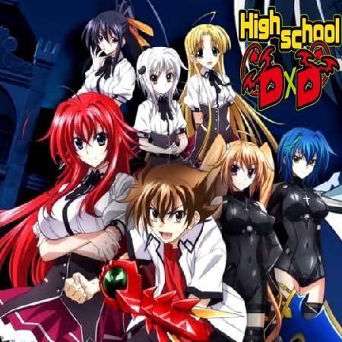

**High School DxD**, a *Japanese* **anime series** filmed on the novel written by Ichiei Ishibumi and illustrated by Miyama-Zero. *High School DxD*'s first *season* was streamed on September 20, 2008. The second season called by *High School DxD* New, streamed from July 7, 2013, to September 22, 2013. Then, the third season called by *High School DxD* Born was broadcasted from April 4, 2015, to June 20, 2015. And then the fourth season called by *High School DxD* Hero was streamed from April 10, 2018, to July 3, 2018. From that year onwards, all the otakus and weebs are eagerly waiting for season 5 of *High School DxD*. So, let's catch up on all the information we've for you.

**High School DxD Season 5: Release Date**

**High School DxD Season 5** is anticipated to be released by the mid of **2021**.

The Passione studio is responsible for the production of *season 5* of *High school DxD* and this studio is known for working on a single anime series at a particular time. After season 4 *release* in June 2019, it worked on Hinako, then on Z/X Code Reunion which was streamed from October 8, 2019, to December 24, 2019, after that it's scheduled to work on the anime 'Project [B.B].' and after this, it's likely to *release season 5* after completion. So, it's solely dependent upon the planned schedule of the Passione studio, *when season 5 will be released*. So, it's speculated that *season 5* will be on the viewers' screen by the mid of *2021*.

**High School DxD Season 5: Expected Plot**

Since the production of *season 5* is officially confirmed so the plot has been decided by the creators of the anime. As per the sources, the director of the anime, Yoshifumi Sueda, revealed that he's going to use a small part of the novel story for *season 5* of the anime. And according to him, there's enough material available in the novel for the adaption into the anime version of the series for *season 5*. 

Passione Studio and the director of the series, Sueda, unveiled that the *High School DxD Season 5* will be in continuation to the 'Hero Oppao Dragon' story arc from the original manga of the series. This arc was started in season 4 and until its completion, it covered two volumes i.e., 9 and 10 from the manga. Since, up till now, all the *season* of the *anime* has been closely adapting the storyline from the manga, so season 5 will likely be adapted from the volume 11 and 12. And even after the 12th volume of the manga, there's enough material in the novel for the production of more seasons after the completion of *season 5*.

The volume 11 storyline starts with the beginning of the Middle-Class Promotion Test. Akeno, Issei, and Kiba will be seen preparing for the test while Koneko will act a little suspiciously after witnessing the closeness upfront of Issei and Rias. There's a twist in the storyline when Ophis and the chief of the Khaos Brigade will be brought to the Hyoudou Residence by the Azazel.

In season 3, the creators got away with the manga storyline and they created their version of the manga story, which was highly disapproved by the viewers. So, the creators are trying to reconcile their mistakes and they're closely following the manga for *season 5*. Since, it's a common result that if an anime is not closely adapted from the manga on which it's grounded, then it's highly likely for that anime series to be disapproved by its fans. So, we're going to see some exciting twists and turns in *season 5* of the *anime*. And as per the production studio of the anime, there'll be a season 6 for the completion of the arc which will be unveiled in *season 5*.

**High School DxD Season 5: Trailer**

Since the production of the *series* has not yet begun for *season 5* of the anime series, so the trailer for that has not been released yet. It's likely to be released by the second half of *2021*. Till that time, you can enjoy the trailer of *High School DxD season* 4😊

https://www.youtube.com/watch?v=OqYc1b3Nud0